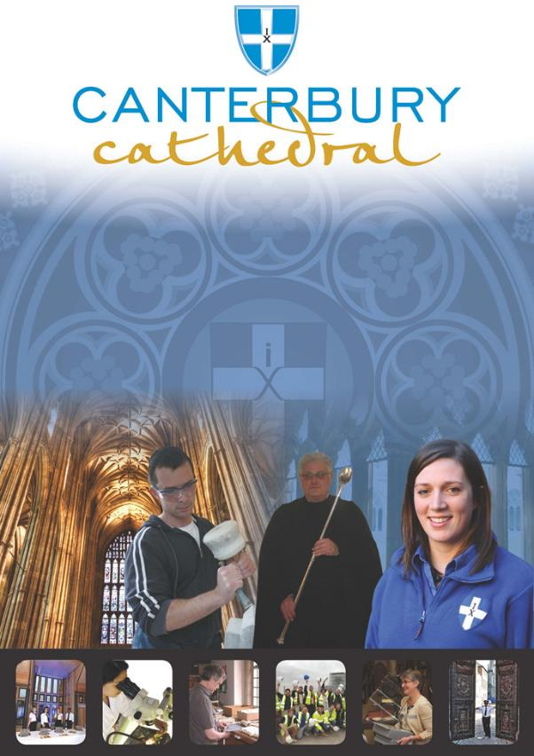

PROFILE OF CANTERBURY CATHEDRAL
St Augustine, the first Archbishop of Canterbury, arrived on the coast of Kent as a missionary to England in 597 AD. He came from Rome, sent by Pope Gregory the Great. It is said that Gregory had been struck by the beauty of Angle slaves he saw for sale in the city market and dispatched Augustine and some monks to convert them to Christianity. Augustine was given a church at Canterbury (St Martin’s, after St Martin of Tours, still standing today) by the local King, Ethelbert whose Queen, Bertha, a French Princess, was already a Christian. This building had been a place of worship during the Roman occupation of Britain and is the oldest church in England still in use. Augustine established his seat within the Roman city walls (the word ‘cathedral’ is derived from the Latin word for a chair ‘cathedra’, which is in turn derived from the Greek ‘kathedra’ meaning seat) and built the first cathedral there. Since that time, there has been a community around the Cathedral offering daily prayer to God; this community is arguably the oldest organisation in the English speaking world. The present Archbishop, The Most Revd Justin Welby, is 105th in the line of succession from Augustine.
Augustine’s original building lies beneath the floor of the Nave. It was enlarged by the Saxons, and rebuilt completely by the Norman Archbishop Lanfranc in 1070 following a major fire. By 1077 his work was complete and his building was described as ‘nearly perfect’. A staircase and parts of the North Wall – in the area of the North West transept also called the Martyrdom – remain from that era. There have been many additions to the building over the last nine hundred years, particularly after the martyrdom of Archbishop Thomas Becket in the Cathedral in 1170: parts of the Quire and some of the windows and their stained glass date from the 12th century.
During the Second World War, the Precincts were heavily damaged by enemy action and the Cathedral’s Library was destroyed. Thankfully, the Cathedral itself was not seriously harmed, due to the bravery of the team of fire watchers, who patrolled the roofs and dealt with the incendiary bombs dropped by enemy bombers.
Today, the Cathedral stands as a place where prayer to God has been offered daily for over 1,400 years; nearly 2,000 services are held each year, as well as countless private prayers from individuals. The Cathedral offers a warm welcome to all visitors – its aim is to show people Jesus, which we do through the splendour of the building as well as the beauty of the worship.

THE WORK OF THE CATHEDRAL
The work of the Cathedral is carried out by over 300 paid staff, supported by some 500 volunteers. The ‘corporate body’ responsible for the management of the Cathedral is the Chapter of Canterbury who are advised by the Cathedral Council and the College of Canons.

The Chapter of Canterbury (Chapter)
The Chapter are responsible for all aspects of the day-to-day management of the Cathedral. Chapter comprises the Dean, the Residentiary Canons, the Receiver General and four additional persons appointed by the Archbishop.

The Cathedral Council
The Council represents the Cathedral community as well as the wider local and regional community. It has 20 members, drawn from a wide variety of organisations. Its duty is to further and support the work of the Cathedral Church in spiritual, pastoral, evangelistic, social and ecumenical areas.

The College of Canons
The College of Canons is composed of 30 Honorary, Lay and Provincial Canons, appointed by the Archbishop and it supports the life of the Cathedral in many different ways.

The Canterbury Cathedral Trust
The Cathedral Trust is a separate charity that is solely for the benefit of the Cathedral. Since 1974, it has assisted with the restoration, maintenance and improvement of the fabric and contents of Canterbury Cathedral and the provision, promotion and encouragement of music.
The Cathedral is well-known all over the world and we welcome more than 1 million visitors and worshippers every year. The Cathedral is more than just a beautiful old building and heritage site; it is a working, living church which maintains a tradition of welcome and worship that has been practiced here for over 1400 years.

Friends
The Friends of Canterbury Cathedral was founded in 1927 by the distinguished scholar and poet Dean George Allen Kennedy Bell. The Organisation was the first of its kind in the world.
The Friends are the Cathedral’s fan club. Admirers of the building, its history and its community, Friends are a part of the Cathedral and work together to preserve it forever, contributing financially - and directly – to many individual and vital projects.

The Cathedral Shop
The Canterbury Cathedral Shop is a large gift shop in the heart of the city of Canterbury. It has an impressive range of high quality gifts, mostly British, and their own exclusive award winning designs.
The Shops wide range of merchandise includes replica historical artefacts, books and CD’s of the world-famous Canterbury Cathedral choir.

THE CANTERBURY JOURNEY
The Canterbury Journey represents a major five-year development of Canterbury Cathedral. The programme will conserve and safeguard this beautiful building’s heritage for future generations and enrich the experience of those who visit.
This essential work is possible thanks to a Heritage Lottery Fund total grant of £13.8 million and the generosity of trusts and individuals in the UK and USA who have given £10.9 million through the Canterbury Cathedral Trust, as well as The Friends of Canterbury Cathedral.
During the course of The Canterbury Journey, the western end of the Cathedral is being restored and enhanced with repairs to the West Towers, Nave roof and Christ Church Gate and landscaping designed to significantly improve access and bring visual coherence to the South Precincts.
A new Welcome Centre will provide information, ticketing services and a shop with a free to enter Viewing Gallery offering stunning never-before-seen views of the Cathedral and Precincts and interpretation.
A purpose-built Community Space will host a range of community activities and events.
New interpretation trails, exhibitions, online resources and a multi-media guide will open up access to the Cathedral’s historic treasures.
A wide-ranging programme of events and activities will attract new and diverse audiences to the Cathedral and a new pass scheme.
The project is formed of three complementary programmes:
Heritage
- Repair and restoration of the West end of the Nave and Christ Church Gate.
- Improved landscaping of the South Precincts.
- Improved physical and digital access to areas of the Cathedral and its collections.
- A commitment to Conservation in Action by engaging people with the work of our craftspeople and the work of the Cathedral.
People
- Opening up access to the Cathedral’s heritage and historic collections through exhibition displays, creative interpretation and a multi-media guide.
- Implementing a Schools Outreach Programme and Loan Box Scheme and enhancing online learning resources.

Communities
- A new Welcome Centre, shop and free to enter Viewing Gallery offering views of the Cathedral and Precincts, interpretation and activities.
- A purpose new purpose-built community space in which to host a wide ranging learning and participation programme including creative activities, workshops, training and community hire.
- A new Precincts pass to encourage the local community to access their Cathedral.

JOB PROFILE
The Community Engagement Intern will support the Community Engagement Manager in the successful planning, management, delivery and evaluation of an innovative and creative community engagement programme of activities as set out in the Cathedral’s approved Activity Plan.
The successful candidate will play a vital role in creating a two way dialogue and positive relationships between the Cathedral and the wider community as well as working across The Canterbury Journey team and with our colleagues responsible for collections, visits, events and communications.
The post holder will support wider learning and community engagement within the Cathedral and outreach activities including the interpretation of heritage and collections, the final stage development of a new Loan Box Scheme and Explorer Backpacks, new online learning resources, creative activities and projects.
This range of activities will allow greater access, in all senses, to the Cathedral’s heritage assets and history both on-site and off-site for the people of Canterbury, Kent and further afield.

The Canterbury Journey aims to:

- Devise and deliver a programme of activities that will offer people the opportunity to explore the Cathedral’s archives and historic collections to help them learn about, and interpret the heritage as well as grow their talents, skills and gifts.
- Deliver and manage specific activities taking place in the new Community Space and Viewing Gallery.
- Engage with local people through a new Pilgrim’s Pass, and use of its database to improve communication and local relationships.
- Increase the number of school visits to the Cathedral through exciting outreach activities, including the development of online teaching resources.
- Support the development of formal and informal learning materials including the development and production of innovative and inspiring Loan Boxes.
- Collaborate with colleagues in opening up the collections as part of the visitor journey with rotating exhibition displays.
- Recruit a diverse team of volunteers and train new and current volunteers to support The Canterbury Journey and wider Cathedral activities.

PRINCIPAL TASKS
Supporting the Community Engagement Manager in the delivery of the following aspects of their role:

Community
- Support the Community Engagement Manager in engaging new, diverse, young and hard-to-reach audiences with the Cathedral’s heritage and collections.
- Support the Community Engagement Manager in broadening the range of audiences accessing the Cathedral’s public programme by championing creative and collaborative practice in community engagement methods.
- Contributing to the delivery, marketing and promotion of the Activity Plan.
- Supporting the partnerships already made with local community groups, government agencies and other organisations involved in community engagement work.
- Coordinate visits to the Cathedral for a variety of community groups.
- Support the development of a drive to attract new, diverse, young and hard-to-reach audiences to Canterbury Cathedral.
- Support the development, planning and delivery of outreach events.
- Initiating, planning, managing and delivering community projects around collections and themed interpretation.
- Maintaining contact with and organising Audience Panel activities.

Learning
- Contribute toward the final stages of development and the delivery of a new Loan Box Scheme and Explorer Backpacks and their supporting materials and trails.
- Contribute toward the production of online learning resources.
- Contribute toward the development of a SE Kent Schools Outreach Roadshow.
- Contributing toward the development and delivery of the Kent schools outreach programme.
- Following on from training, deliver workshops, activities and events in schools and with community groups alongside the Community Engagement Manager.
Volunteers and work placements
- Support the recruitment of volunteers and work placements.
- Coordinate and manage volunteer and work placement activity.
- Administer and record volunteer and work placement contribution and outputs.

Events
- Work with the Community Engagement Manager in planning, managing and delivery of events and activities, both at the Cathedral and in outreach locations/ venues.
- Evaluating activities.

Projects
- Take an active role in the delivery of The Memory Project which will initially involve managing volunteers as they record oral history interviews, recruiting and supporting interviewees and managing a volunteer photographer.

General
- Contributing toward the Learning and Participation monthly report.
- To attend training sessions as and when required;
- To be aware of the fire and Health and Safety policies and procedures.
- To carry out any routine task that may be required by The Chapter of Canterbury.

PERSONAL SPECIFICATION
The personal specification below indicates the qualifications, experience, knowledge and skills required to undertake the role effectively.
Essential:
- An interest in the Heritage and Collections of Canterbury Cathedral.
- An interest in engaging a range of community audiences with events and activities.
- An appreciation for the culturally and socially diverse nature of community, including families and hard-to-reach groups and sensitivity to different needs, interests and beliefs.
- An awareness of how to deliver programmes for people with differing learning and physical abilities.
- An awareness of local community organisations and how Canterbury Cathedral may be able to support them with the resources available through The Canterbury Journey.
- An awareness of the issues and initiatives affecting places of worship, heritage sites and museums around social cohesion.
- Excellent verbal and written skills, particularly communicating effectively with people of all ages, cultural backgrounds and beliefs.
- Understanding of, and being in sympathy with, the role, mission and enterprise of Canterbury Cathedral.

Desirable:

- Experience in engaging a range of community audiences with collections, including the Archives, Library, objects and artworks, through a variety of high-quality learning and participation programmes.
- The ability to use handling collections and objects to inspire and educate.
- Driving license and own transport necessary to be able to fulfill community engagement and outreach work across East Kent and beyond as necessary.

KEY WORKING RELATIONSHIPS

- Reporting to the Community Engagement Manager.
- Membership of the Learning and Participation Team.
- Volunteer training/ coordination/ management teams in the Cathedral.
- Cathedral Visits’, Events, Communications and Schools’ Departments staff.
- Working closely with the Collections Manager to ensure heritage and the historic collections (including Archives, Library, craft, objects and artworks) are at the core of learning and participation activities.

TERMS AND CONDITIONS

Grade

Intern
Duration

This post is offered as an 11 month fixed-term contract.

Working hours

Normally 21 hours per week, Monday to Friday, however the position holder should be flexible in their approach to hours worked as these will be dictated by operational need and will require some weekend or evening work.

Bursary

£8,198 (Paid over 11 months and based on 21 hours per week)

Probation Period

All new posts are subject to a probation period of three months. The Intern will meet regularly with their line manager to assess both formally and informally, progress on work and performance.

Annual holiday

The annual entitlement is 25 days, plus 8 public holidays and 2 Dean and Chapter Days.

Based on the 11 month duration of this post, the entitlement is 135 hours, calculated on a pro rata basis of annual entitlement and inclusive of public holidays and Dean and Chapter days.

Pension scheme
The Chapter of Canterbury offer a Stakeholder pension to all employees. Your age and salary will determine if you are to be automatically enrolled into the pension scheme
The Chapter of Canterbury contribute 7.5% of salary into a Stakeholder Pension Scheme. Staff in the pension scheme are insured against death in service 3 x annual salary to the age of 70.

Training
Training needs are assessed continuously and provision made where required.

Parking

Chapter is not able to offer parking on site.

Employee benefits

We are able to offer a range of employee benefits including discounts in local shops, restaurants and sports centres.

EQUALITY STATEMENT
The Chapter of Canterbury recognises that discrimination and victimisation is unacceptable and that it is in the interests of the organisation and its employees and volunteers to utilise the skills of the total workforce. It is the aim of the organisation to ensure that no employee, volunteer or job applicant receives less favourable facilities or treatment (either directly or indirectly) in recruitment or employment on grounds of age, disability, gender / gender reassignment, marriage / civil partnership, pregnancy / maternity, race, religion or belief, sex, or sexual orientation.
PERSONAL DATA
As your employer, The Chapter of Canterbury needs to keep and process information about you for normal employment purposes. The information we hold and process will be used for management and administrative use only. To comply with the General Data Protection Regulations, your acceptance of these terms and conditions gives your consent for your data to be processed.
July 2018

This job description is provided to assist the post holder to know their principal duties. It may be amended from time to time in consultation with the post holder, by, or on behalf of, the Head of the Department, without change to the level of responsibility appropriate to the grading of the post.

HOW TO APPLY

A CV should be submitted on line via our web page.

Application details can be found at:

http://canterbury-cathedral.org/get-involved/employment/vacancies

Please state in your application the skills and experience you will bring and how this internship will benefit you.

The Community Engagement Manager, Liam O’Driscoll, is happy to answer queries informally on the contact details below.

Liam O’Driscoll - Community Engagement Manager
Canterbury Cathedral, Cathedral House, 11 The Precincts, Canterbury, Kent. CT1 2EH

Email: liam.odriscoll@canterbury-cathedral.org
Mobile: 07771 800 486 Direct: +44 (0) 1227 862 796

The closing date for this post is:

Sunday 23 September 2018.

Interviews are expected to take place:

Wednesday 3 October 2018.

Post will commence:

Monday 5 November 2018.

